PROJECT REPORT
Script-Controlled ACL – Restrict Record Access Based on Field Value
Project Report Format

PROJECT REPORT FORMAT
1. INTRODUCTION
1.1 Project Overview
Project Overview: This project demonstrates how ServiceNow Access Control Lists (ACLs) can be configured to control record-level access using field conditions and script-based authorization. An Institution Details table is used as the working example, where access is controlled so that only records satisfying the configured access criteria can be viewed by an authorized user.
1.2 Purpose
Purpose: The purpose of this project is to provide controlled access to ServiceNow records and prevent unauthorized users from viewing restricted information. The solution demonstrates how ACL configuration, conditions, and scripting can be combined to implement a practical record-access control mechanism.
2. IDEATION PHASE
2.1 Problem Statement
Problem Statement: In a ServiceNow application, users may have access to a table but should not automatically be allowed to view every record in that table. Without record-level restrictions, sensitive or department-specific information may be exposed to users who do not require it. Therefore, a controlled mechanism is required to restrict record access according to the defined business condition and authorization logic.
2.2 Empathy Map Canvas
Empathy Map Canvas: The empathy map identifies what the intended users see, think, say, do, hear, and feel while working with restricted records. It helps the project team understand the user's need for secure but usable access, reducing unnecessary exposure of records while allowing authorized work to continue.
2.3 Brainstorming
Brainstorming: Brainstorming was used to identify possible ways of implementing record-level security in ServiceNow. The alternatives considered include role-based ACLs, condition-based ACLs, scripted ACLs, and combinations of these approaches. The selected approach uses the ServiceNow ACL mechanism with a field-based condition and script-controlled authorization.
3. REQUIREMENT ANALYSIS
3.1 Customer Journey Map
Customer Journey Map: The customer journey describes the sequence followed by a user when attempting to access an Institution Details record. It covers login, navigation to the target table, record access evaluation by the ACL, and the final result. Mapping these stages helps identify where authorization must be applied.
3.2 Solution Requirement
Solution Requirement: The system must provide secure record-level access to the Institution Details table. The ACL should evaluate the configured condition and authorization logic before allowing a user to read a record. The solution should be simple to maintain, consistent with ServiceNow security practices, and capable of producing a clear allowed or denied access result.
3.3 Data Flow Diagram
Data Flow Diagram: The data flow shows how a user request moves through the ServiceNow platform. The user requests a record, ServiceNow evaluates the applicable ACL, the configured condition and script are processed, and the platform either permits or restricts access to the record. This illustrates the security decision point between the user request and the returned data.
3.4 Technology Stack
Technology Stack: The project is implemented using ServiceNow as the platform, ServiceNow ACLs for access control, the Institution Details custom table for sample data, and JavaScript-based ACL scripting where advanced authorization logic is required. The implementation is configured through the ServiceNow platform interface.
4. PROJECT DESIGN
4.1 Problem-Solution Fit
Problem-Solution Fit: The proposed solution directly addresses the problem of unrestricted record visibility by introducing an ACL-based authorization layer. Instead of relying only on table-level permissions, the solution evaluates record access against the configured business rule and authorization logic.
4.2 Proposed Solution
Proposed Solution: A read ACL is created for the Institution Details table. The ACL is configured with the required access condition, including the Branch condition used in the implementation, and an advanced script for additional authorization control. When a user requests a record, ServiceNow evaluates these controls before displaying the record.
4.3 Solution Architecture
Solution Architecture: The architecture consists of the user, ServiceNow application, Institution Details table, ACL rule, condition evaluation, and script evaluation. The user request reaches the target table, the ACL checks the configured restrictions, and ServiceNow returns the record only when the access evaluation succeeds.
5. PROJECT PLANNING & SCHEDULING
5.1 Project Planning
Project Planning: The project was planned in stages covering requirement identification, ServiceNow table creation, sample record creation, ACL configuration, condition and script setup, functional testing, evidence collection, documentation, and final validation. This sequence ensures that each implementation stage is completed before the next stage is verified.
6. FUNCTIONAL AND PERFORMANCE TESTING
6.1 Performance Testing
Performance Testing: Performance testing checks whether the access-control implementation behaves consistently when records are requested. The focus is on response behavior, correct ACL evaluation, and ensuring that the security rule does not cause unexpected access or functional issues during normal usage.
7. RESULTS
Output Screenshots
S.No | Description | Screenshot
1 | Institution Details record list after ACL | 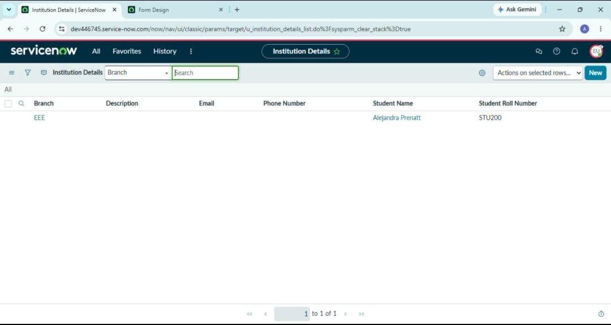
2 | Final access result – EEE record visible
7.1 Output Screenshots
Output Screenshots: This section presents the final visible results of the implementation. The screenshots provide evidence of the configured records and the resulting access behavior after the ACL rules have been applied.
Screenshot Evidence
Screenshot Evidence: This section documents the implementation steps that support the final result. Each screenshot is placed in sequence so that the reviewer can verify table creation, record preparation, ACL configuration, field condition, advanced script, and the final access result.

A. Source Code
Actual ServiceNow ACL script used in the Advanced ACL configuration:
(function () {
if (gs.hasRole('bb1')) {
return true;
}
// Deny access for all others
return false;
})();

B. GitHub & Project Demo Link
GitHub Repository: https://github.com/amrinbegum21122006-web/Script-Controlled-ACL-Restrict-Record-Access-Based-on-Field-Value
Project Demo: https://drive.google.com/file/d/1BF0a-5ittC7Bxwb3czwaLBoVP7lvx2Y0/view?usp=drivesdk

C. Screenshot Evidence
Attach final screenshots showing the target list, ACL configuration, test record and access result.
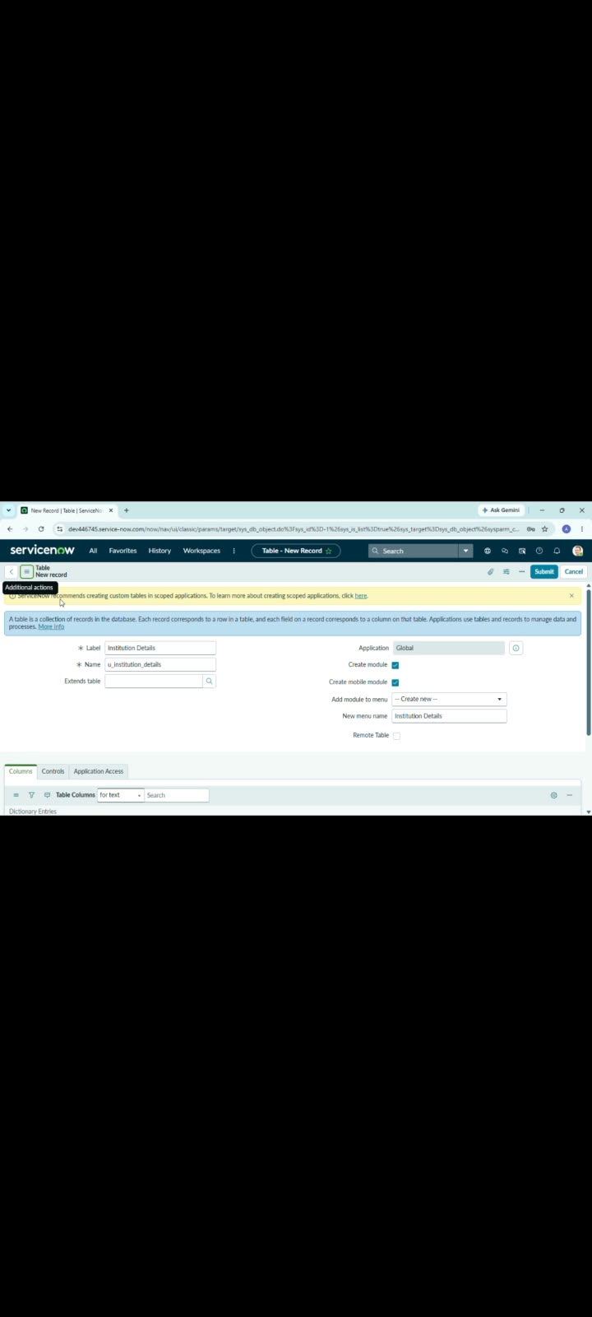
1. Table Creation – Institution Details
2. Institution Details Record List
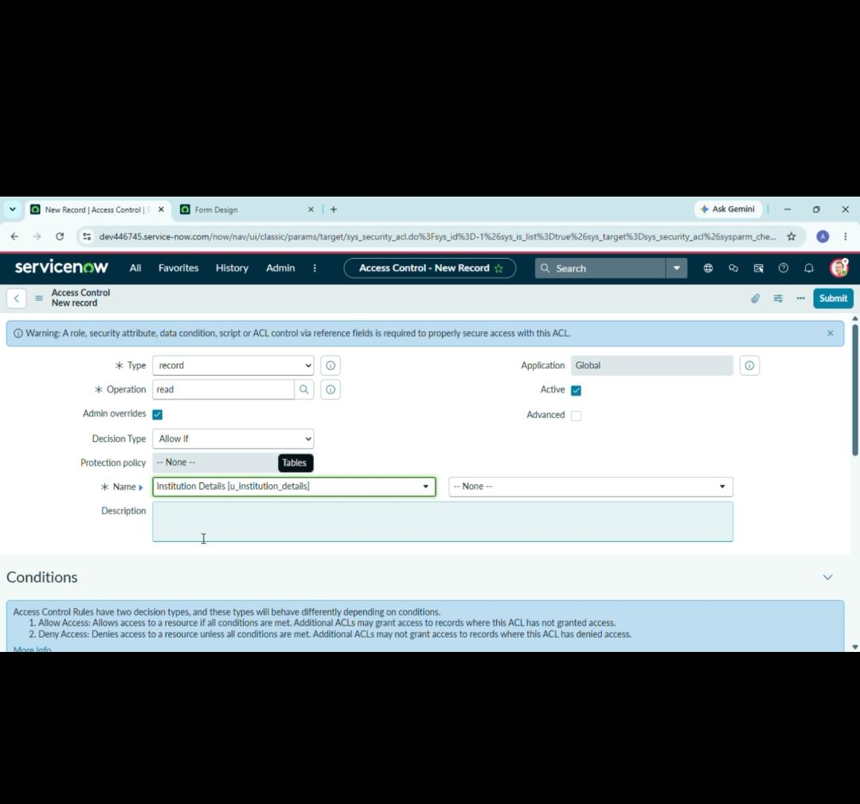
3. ACL Configuration
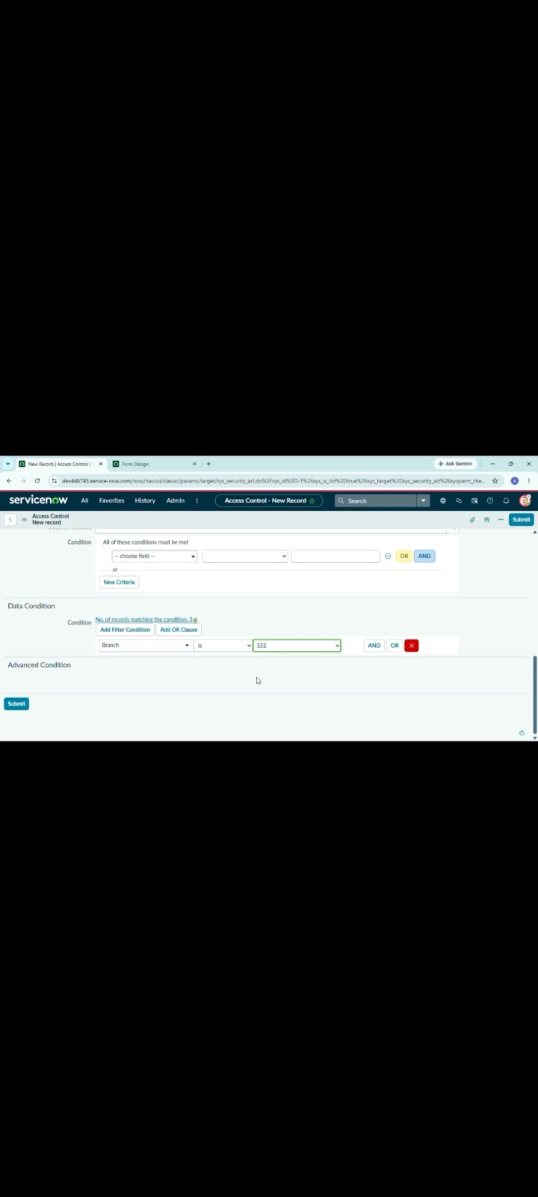
4. ACL Condition – Branch is EEE
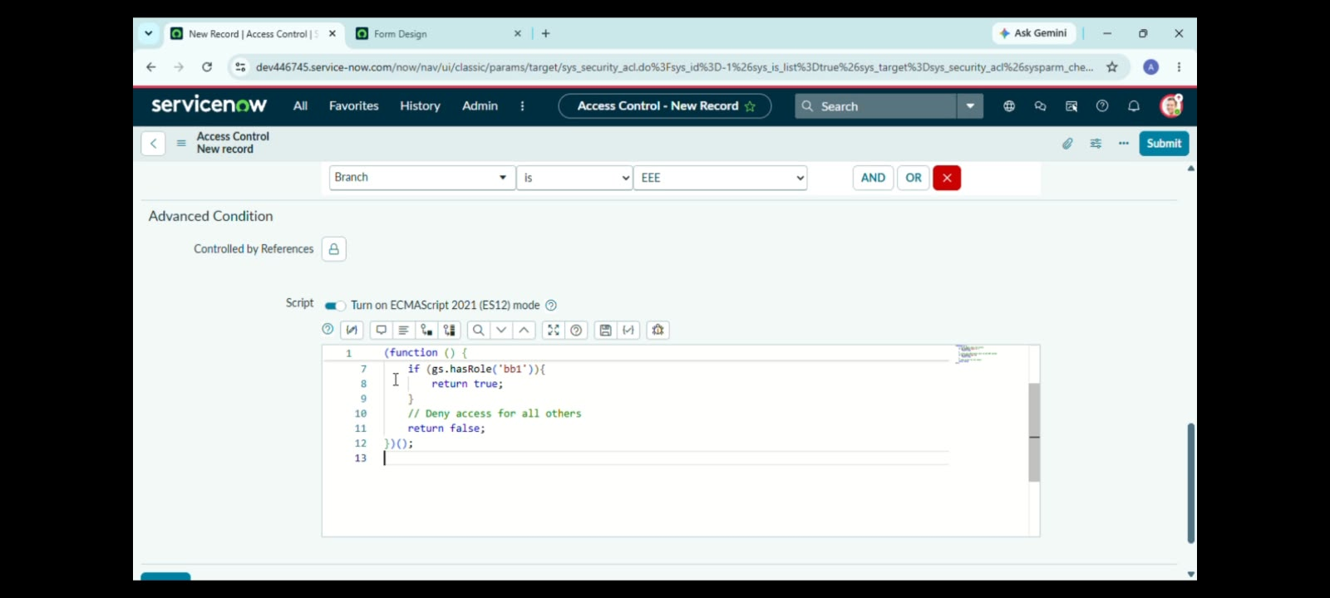
5. Advanced ACL Script
6. Final Access Result

